**Light Sensor: is a photoelectric device that converts light energy (photons) detected to electrical energy (electrons).**

**The Light Intensity Sensor Units**

**Candela**

* Originated from the term candles, candela refers to luminous intensity; how strong the light is to a naked eye
* The higher the luminous intensity, the higher the sensitivity it is to our eyes
* So, for instance, if you have a bulb that produces visible light in different directions with a luminous intensity of 20 candelas, your luminous flux will be 251 lumens.
* And this applies if you multiply the luminous intensity by the full 4π steradians. Hence, regardless of the concentration or reflection of light, this bulb will generate 251 lumens of luminous flux.

**Lumen**

* Lumen = Total amount of light emitted in all directions
* Measures the total amount of visible light from a light source through the relationship between luminous intensity and the angle that a light beam fills
* Commonly used to rate the brightness of a lightbulb

**Lux**

* Lux = total amount of light that falls on a particular surface
* Used to measure illuminance, the area where the luminous flux is spread
* It’s similar to Lumen but it takes into account the surface area
* lux represents a lumen for every square meter.

**Types:**

**BH1750FVI Digital Light Sensor: This sensor is widely used due to its high sensitivity and ability to measure a wide range of light levels. It communicates over I2C and provides accurate readings.**

**Information:**

**1-Digital Output: The sensor provides digital output, making it easy to interface with microcontrollers and digital circuits.**

**2-High Sensitivity: It has high sensitivity to light, allowing it to accurately measure light intensity even in low-light conditions.**

**3-Wide Measurement Range: The sensor has a wide measurement range, typically from 1 lux to 65,535 lux, which covers a broad spectrum of lighting conditions.**

**4-Low Power Consumption: It operates on low power, making it suitable for battery-powered devices and energy-efficient applications.**

**5-Compact Size: The sensor is small and compact, making it easy to integrate into various electronic devices and systems.**

**Price:264**

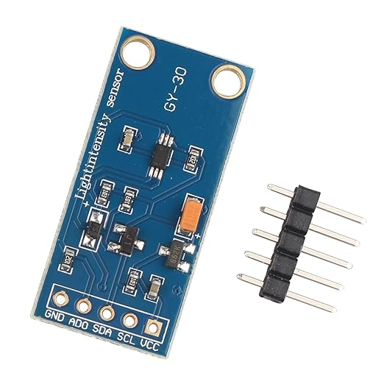

**TSL2561 Luminosity Sensor: Another popular sensor known for its high sensitivity and ability to measure both visible and infrared light. It offers adjustable gain settings and communicates over I2C or SMBus.**

**Is the best because:**

**1-High Sensitivity: The TSL2561 sensor offers high sensitivity across a wide range of light levels, allowing it to detect both low and bright light conditions accurately.**

**2-Wide Dynamic Range: It has a wide dynamic range, enabling it to capture subtle changes in light intensity as well as handle high-intensity light sources without saturation.**

**3-Dual Photodiode Design: The TSL2561 sensor features dual photodiodes with different spectral responses, allowing it to accurately measure both visible and infrared light levels.**

**4-Digital Output: It provides digital output in lux (luminance) units, making it easy to interface with microcontrollers or development boards for further processing and analysis.**

**5-Programmable Integration Time and Gain: The TSL2561 sensor allows users to adjust the integration time and gain settings to optimize performance based on the specific lighting conditions of the application.**

**6-Low Power Consumption: Despite its high sensitivity and performance, the TSL2561 sensor consumes low power, making it suitable for battery-operated and portable devices.**

**7-I2C Interface: It communicates with microcontrollers or development boards via the I2C (Inter-Integrated Circuit) interface, which is widely supported by most embedded systems.**

**8-Compact Size: The TSL2561 sensor is compact and lightweight, making it easy to integrate into various electronic devices and applications.**

**Price: 494EGP**

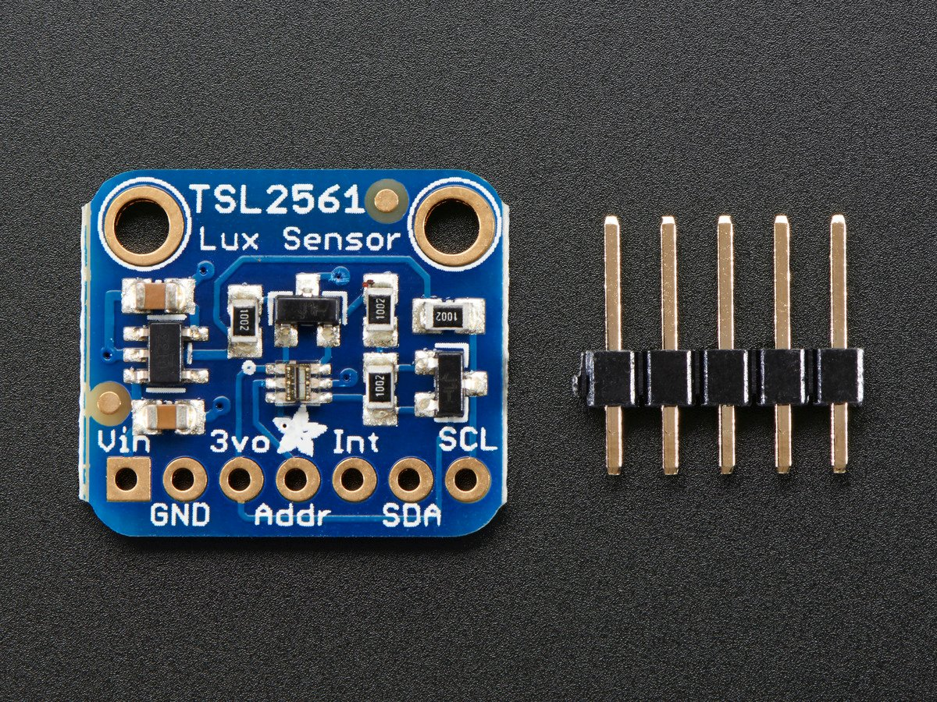

**TEMT6000 Ambient Light Sensor: This sensor is commonly used for basic light intensity measurements. It's simple to use and offers analog output proportional to light intensity.**

**Price:284**

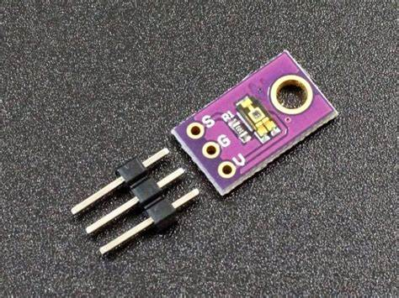

**Mean price:347.33**

**Humidity Sensor:**

**1-** **DHT22 (or AM2302) Temperature and Humidity Sensor: The DHT22 is a widely used sensor known for its relatively high accuracy and low cost. It provides both temperature and humidity readings and communicates over a single-wire digital interface. It's easy to use and suitable for a wide range of applications.**

**Price: 300EGP**

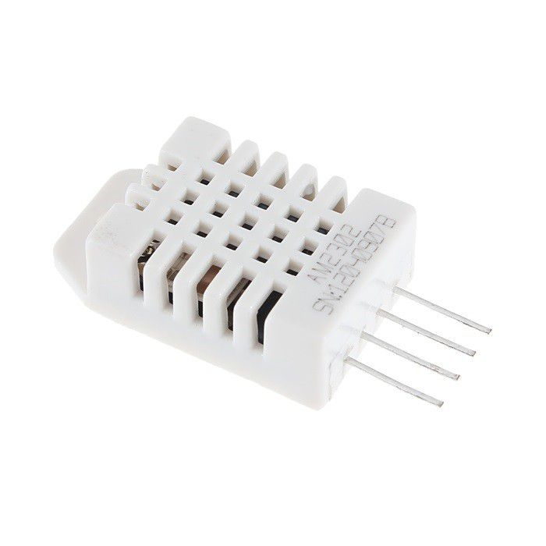

**2-** **BME280 Environmental Sensor: While primarily known for its temperature, pressure, and humidity capabilities, the BME280 offers excellent humidity sensing performance. It communicates over I2C or SPI and provides accurate readings in various environmental conditions.**

**This is The best because the Information:**

**1-Multi-Sensing Capabilities: The BME280 sensor integrates temperature, humidity, and pressure sensing capabilities into a single chip, allowing for comprehensive environmental monitoring in various applications.**

**2-High Accuracy: The BME280 sensor offers high accuracy in temperature, humidity, and pressure measurements, making it suitable for applications where precise environmental monitoring is required.**

**3-Wide Measurement Range: It can measure temperature in the range of -40°C to +85°C, humidity in the range of 0% to 100%, and barometric pressure in the range of 300 hPa to 1100 hPa.**

**4-Compact and Low Power: The BME280 sensor is compact in size and consumes low power, making it suitable for battery-operated and portable devices, as well as IoT applications where power efficiency is essential.**

**5-Digital Interface: It communicates with microcontrollers or development boards via standard digital interfaces such as I2C (Inter-Integrated Circuit) or SPI (Serial Peripheral Interface), enabling easy integration into various electronic systems.**

**6-Calibration Data: The BME280 sensor comes with built-in calibration data stored in its memory, ensuring accurate measurements without the need for additional calibration procedures.**

**7-Flexible Operating Modes: It offers multiple operating modes to balance between measurement accuracy and power consumption, allowing developers to optimize performance based on specific application requirements.**

**8-Wide Range of Applications: The BME280 sensor is suitable for a wide range of applications, including weather stations, indoor climate monitoring, altitude sensing, navigation systems, and industrial automation.**

**Price: 363 EGP**

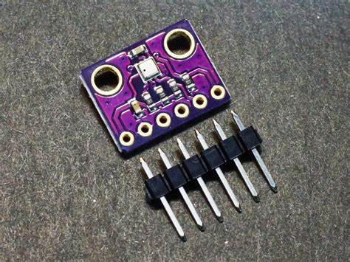

**3-DHT11:**

**Moderate Accuracy: While the DHT11 sensor provides temperature and humidity readings, its accuracy is moderate compared to more advanced sensors. It may have deviations in readings, especially in extreme environmental conditions.**

**Limited Range and Resolution: The DHT11 sensor has a limited range for temperature and humidity measurements and provides relatively low resolution compared to higher-end sensors. It may not be suitable for applications requiring precise or extended range measurements.**

**Price: 54 EGP**

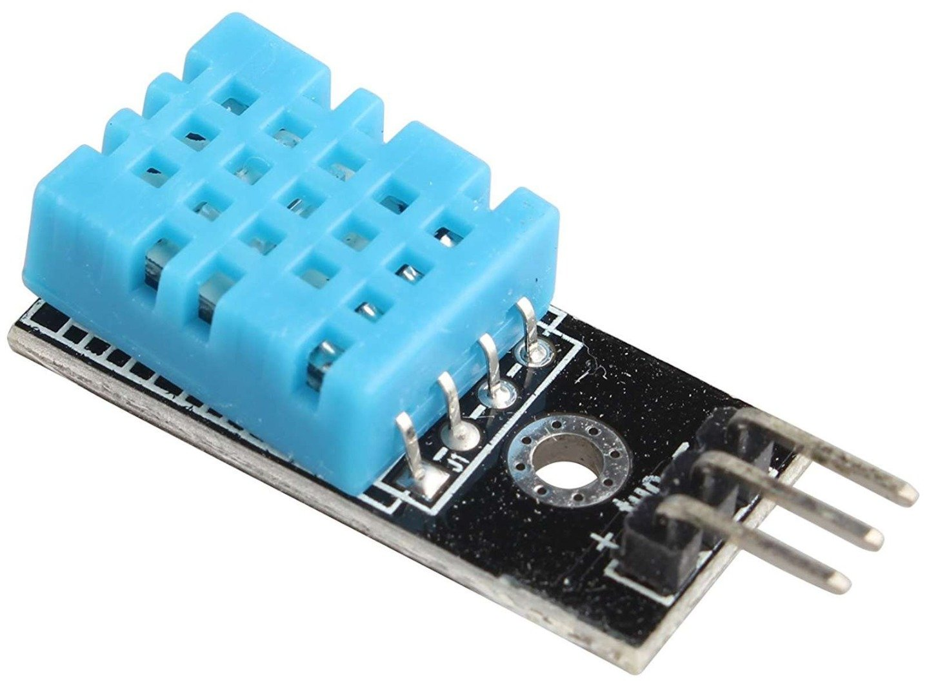

**Mean price: 239**

**Soil Moisture Sensor:**

**1-Measures Soil Moisture Content: Soil moisture sensors accurately measure the water content in the soil, providing valuable information about soil conditions.**

**2-Helps Optimize Irrigation: By monitoring soil moisture levels, farmers can optimize irrigation schedules and water usage, ensuring that plants receive the appropriate amount of water for healthy growth while minimizing water wastage.**

**3-Prevents Overwatering and Underwatering: Soil moisture sensors help prevent overwatering or underwatering of plants by providing real-time data on soil moisture levels. This can prevent waterlogged soil conditions or drought stress, leading to improved plant health and yield.**

**4-Saves Water and Reduces Costs: By optimizing irrigation practices based on soil moisture data, farmers can save water and reduce water-related costs, such as pumping and water bills.**

**5-Easy to Install and Use: Most soil moisture sensors are easy to install and use, requiring minimal setup and maintenance. They can be buried in the soil near the root zone of plants and connected to data logging systems or irrigation controllers for automated monitoring and control.**

**6-Various Sensing Technologies: Soil moisture sensors utilize various sensing technologies, including capacitance, resistance, and dielectric measurement, to measure soil moisture accurately. Each technology has its advantages and is suitable for different soil types and applications.**

**7-Wireless Connectivity: Some soil moisture sensors come with wireless connectivity options, allowing users to monitor soil moisture levels remotely using smartphones or computers. This enables farmers to access real-time data and make informed decisions from anywhere.**

**Price: 81 EGP**

